|  |  |
| --- | --- |
| **Create table**  **Exercise Projects** |  |

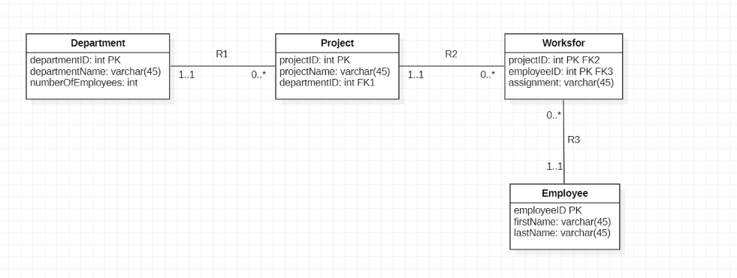

## Create a schema ‘projects’

## Exercise 1

Create the tables of the ERD Projects. Make sure that also the primary keys, NOT NULL constraints and the reference keys are defined. Name should not be empty.

## Exercise 2

Fill the different tables with the supplied script. If the script doesn’t work properly, it means that you didn't create the tables correctly, so try to fill table by table.

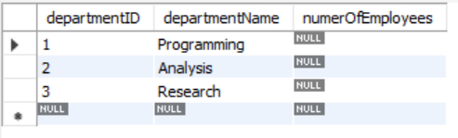

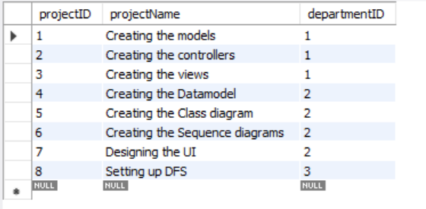

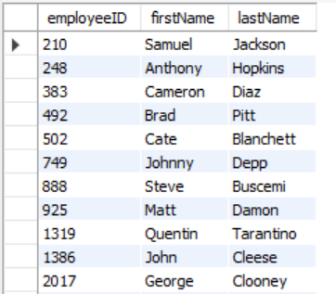

20 employees

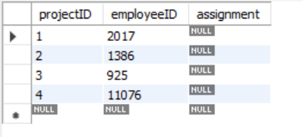

## Exercise 3

Show the data of all projects.

Change the assignment of all employees working on project 3 to "Write CSS/html".

## Exercise 4

Try to remove the employee with employee number '1386' from the employee table. Is this possible? Why (not)?

## Exercise 5

Delete the different tables and the schema 'projects'.